**DAILY ONLINE ACTIVITIES SUMMARY**

|  |  |  |  |  |  |  |  |
| --- | --- | --- | --- | --- | --- | --- | --- |
| **Date:** | **18/05/2020** | | | | **Name:** | **Tushit Shukla** | |
| **Sem & Sec** | **4 sem & B sec** | | | | **USN:** | **4AL18CS093** | |
| **Online Test Summary** | | | | | | | |
| **Subject** | | **DESIGN AND ANALYSIS OF ALGORITHM IA Test** | | | | | |
| **Max. Marks** | | **30** | | **Score** | |  | |
| **Certification Course Summary** | | | | | | | |
| **Course** | 1. [Introduction to Cyber security](https://olympus.greatlearning.in/courses/12628) | | | | | | |
| **Certificate Provider** | | | **Great Learning** | **Duration** | | | **1s hr(spent by me on that day to learn)** |
| **Coding Challenges** | | | | | | | |
| **Problem Statement:**   1. Hint: An Anagram of a string is another string that contains same characters, only the order of characters can be different. For example, "act" and "cat" are anagram of each other. 2. Write down a java program to print even and odd numbers series respectively from two threads: t1 and t2 synchronizing on a shared object Let t1 print message “ping — >” and t2 print message “,—-pong”.   Take as command line arguments, the following inputs to the program: Sleep Interval for thread t1 Write down a java program to print even and odd numbers series respectively from two threads: t1 and t2 synchronizing on a shared object  Let t1 print message “ping — >” and t2 print message “,—-pong”.  Take as command line arguments, the following inputs to the program: Sleep Interval for thread t1 Sleep Interval for thread t2 Message per cycle No of cycles  . | | | | | | | |
| **Status: Completed** | | | | | | | |
| **Uploaded the report in Github** | | | | **Yes** | | | |
| **If yes Repository name** | | | | <https://github.com/tushitshukla29/lockdown-program> | | | |
| **Uploaded the report in slack** | | | | **Yes** | | | |

**Online Test Details**

MATHS TEST Details: 18CS45 online test was scheduled from 9:30 am to 10:10 am. The portion for the IA was 1st module, the questions were MCQ type.

**Online Certification Details**: Blockchain in Cybersecurity

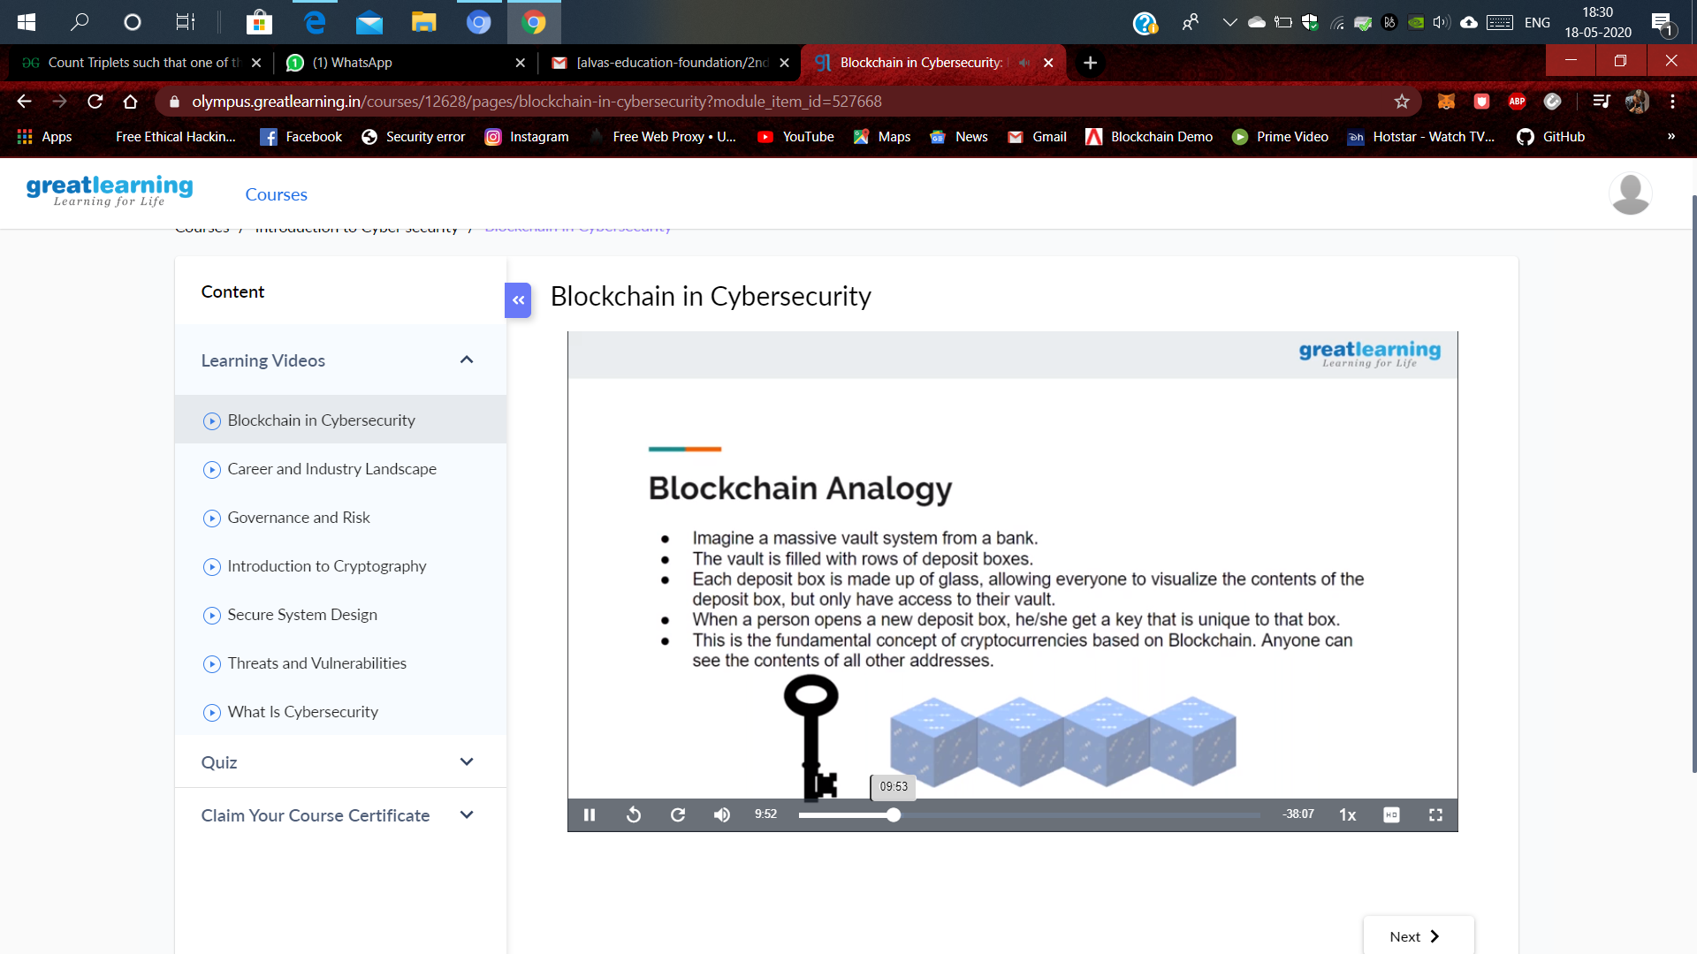

**Coding Challenge Detail :** I have written programs and uploaded it to my Github repository.

Link as follows: 1. <https://github.com/tushitshukla29/lockdown-program/blob/master/Oddandeventhread.java>

2 <https://github.com/tushitshukla29/lockdown-program/blob/master/anagram.c>